PRESS OFFICE
ptsecurity.com, +7 495 744 01 44, pr@ptsecurity.com
vk.com/ptsecurity, t.me/Positive_Technologies, x.com/ptsecurity, vk.com/phdays

Press release
February 27, 2025, Moscow

Positive Technologies helps fix vulnerabilities in XWiki, a platform for creating wiki sites

PT SWARM experts Alexey Solovyov and Evgeny Kopytin have discovered three vulnerabilities in the open-source platform XWiki, which companies use to create wiki sites. Successful exploitation of these security flaws could have allowed an attacker to steal employee data and block access to XWiki, thereby disrupting a company's operational processes. The project's developer was notified of the threat under the responsible disclosure policy and has released a software update.

Vulnerability PT-2025-30704 (CVE-2025-32429, BDU:2025-09129) was assigned a CVSS v4.0 score of 9.3 out of 10, corresponding to a critical threat level. The other two flaws were combined under a single identifier, PT-2025-31942 (CVE-2025-32430, BDU:2025-06941), and received a score of 6.5 each.

Since June 2022, over 25,000 wiki sites have been launched on XWiki, and the number of users in 2025 exceeded 14 million, according to information on the platform's website. During threat intelligence monitoring, Positive Technologies experts determined that potentially more than 21,000 devices with XWiki installed are vulnerable worldwide. The majority of these were recorded in Germany (26%), the USA (19%), France (18%), Hong Kong (6%), and Russia (5%).

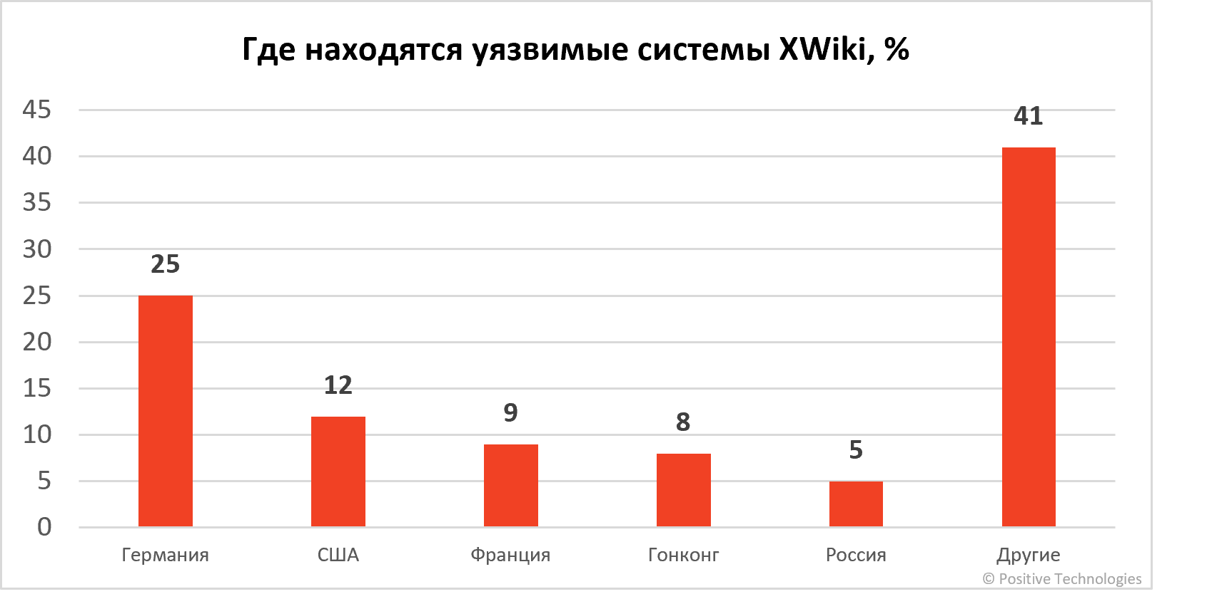
Distribution of vulnerable XWiki systems by country

Successful exploitation of vulnerability PT-2025-30704 would lead to a failure in XWiki's operation, potentially disrupting business processes and causing negative repercussions from the affected company's clients and partners. Restoring access to the information hosted on the platform would require additional resources. Meanwhile, the PT-2025-31942 flaws would allow an attacker to carry out a social engineering attack. By tricking an administrator, the attacker could execute arbitrary code on the server and establish a foothold. This would grant the attacker access to confidential data and enable them, for example, to move laterally within the corporate network to attack employee workstations and internal servers. To remain protected, users must update XWiki to the latest version as soon as possible.

"When a specially crafted HTTP request was sent from an unauthenticated user, the platform did not sanitize all input data, which would allow an attacker to inject SQL (HQL) code. However, vulnerability CVE-2025-32429 cannot be called standard, as the possibilities for its exploitation were limited by XWiki's specific architecture," commented Alexey Solovyov, Head of the Web Application Security Analysis Expert Group at Positive Technologies. "By successfully exploiting this flaw, an attacker could send numerous HTTP requests to the database with a 'sleep' command, overloading XWiki and causing a denial of service."

According to Evgeny Kopytin, successfully exploiting PT-2025-31942 required a user to click on a specially crafted link, after which malicious JavaScript code would be executed in their browser. A cross-site scripting (XSS) attack carried out against a regular user would allow the attacker to escalate their privileges within XWiki. If the victim were a platform administrator, the attacker would gain the ability to read and edit the company's confidential data. The attacker could also execute arbitrary code on the server, allowing them, for example, to replace corporate page addresses with links to phishing resources and steal employee credentials. If the server running XWiki were located within the organization's local network, the attacker could pivot and launch further attacks against other devices.

Such vulnerabilities can arise in various solutions that have complex architectures and a wide range of features. For instance, in early 2025, PT SWARM specialists Alexey Solovyov and Yan Chizhevsky discovered errors in the NetCat CMS website management system PT-2024-5669–PT-2024-5691, also related to SQL injection and cross-site scripting. Specialized tools are necessary to ensure the security of a large number of actively developing components.

Advanced NTA (NDR) class systems, such as PT Network Attack Discovery (PT NAD), can detect attempts to exploit such vulnerabilities, and NGFW-class products, like PT NGFW, can block attacks that use them. Identifying security gaps at the product development stage is possible using static code analyzers, such as PT Application Inspector. To block vulnerability exploitation attempts, we recommend using web application firewalls, for example, PT Application Firewall, which also has a cloud version — PT Cloud Application Firewall.

Stay informed about current security weaknesses on the dbugs portal, which aggregates data on vulnerabilities in software and hardware from manufacturers worldwide, along with vendor recommendations for remediation.

Positive Technologies is an industry leader in result-driven cybersecurity and a major global provider of information security solutions. Our mission is to safeguard businesses and entire industries against cyberattacks and non-tolerable damage. Approximately 3,000 organizations worldwide use technologies developed by our company. Positive Technologies is the first and only cybersecurity company in Russia on the Moscow Exchange (MOEX: POSI), with 220,000 shareholders and counting. Follow us on X, LinkedIn, and in the News section at global.ptsecurity.com.

